LDR Simple Light Sensor Interfacing to Arduino:
Introduction:
The LDR is a variable resistor, whose resistance varies based on the light incident upon it. More the light, less the resistance. Now the LDR cannot be used directly. We would need to convert the change in resistance of the ldr to change in voltage. We can achieve this by constructing a potential divider using the ldr and a fixed resistor. Then we can take the output of the potential divider and connect it to an Analog In pin on the arduino.
Requirment:
- Simple Light Sensor
- 1k Resistor
- Arduino Board
- Breadboard

Hardware configuration:

Step1:Place the LDR as breadboard and connect a resistor one end of LDR.

Step2:Connect Supply & Ground. Take a Wire from the Junction of the Resistor & LDR and connect it to Analog In 0 of the Arduino

Step3:For this setup 5v power supply requried connected Arduino 5v pin to breadboard and
properly ground.
The final setup of LDR as lock like below.

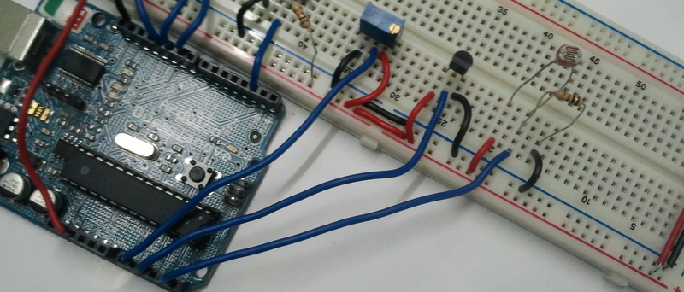

Programing:(source code):

Programming to control the LDR simple Sensor:

/*
** Nightlight LDR test program
*/

int sensorPin = A0; // select the input pin for the ldr
unsigned int sensorValue = 0; // variable to store the value coming from the ldr

void setup()
{
pinMode(13, OUTPUT);
//Start Serial port
Serial.begin(9600); // start serial for output - for testing
}

void loop()
{
// read the value from the ldr:
sensorValue = analogRead(sensorPin);
if(sensorValue<400) digitalWrite(13, HIGH); // set the LED on
else digitalWrite(13, LOW); // set the LED on

// For DEBUGGING - Print out our data, uncomment the lines below
//Serial.print(sensorValue, DEC); // print the value (0 to 1024)
//Serial.println(""); // print carriage return
//delay(500);
}
Installation:
The source code copy to the skeches of arduino and compile (there is verify option) as shown given below.
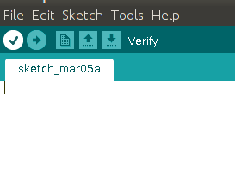

And then uploding the source code.(there is uploding option) to the Arduino board.(software) as shown given below.
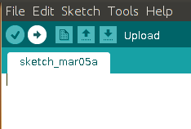

Troubleshooting:
FAQ:
Maintainers:
Duryodhan Aldar (durva.ges@gmail.com)

References: http://quickstartkitforarduino.blogspot.in/

